**Programming in C++ Bright Student Assignment Questions**

**CO1 related Assignment Questions**

1. Define a class named “Bank” having data members i.e. customer id, name, balance and city. Provide necessary member functions to initialize the data members and to display the data members. Also develop the following member functions:

* Credit() -> To deposit the amount in the customer’s account.
* Debit() -> To withdraw money from the customer’s account. While withdrawing money, minimum balance of Rs. 1000 should be remained in the account.
* getBalance() -> To get the balance of the customer.

Write a C++ program to test the functionality of the Bank class.

1. Considering the following scenario of problem statement, define a class named “Employee” having appropriate data members, setter and getter member functions. Define 2 member functions i.e. “grossSal()” and “netSal()” to display gross salary and net salary(after deducting income tax amount) respectively. Test the functionality of Employee class by creating array of objects. (more than 1 employees)

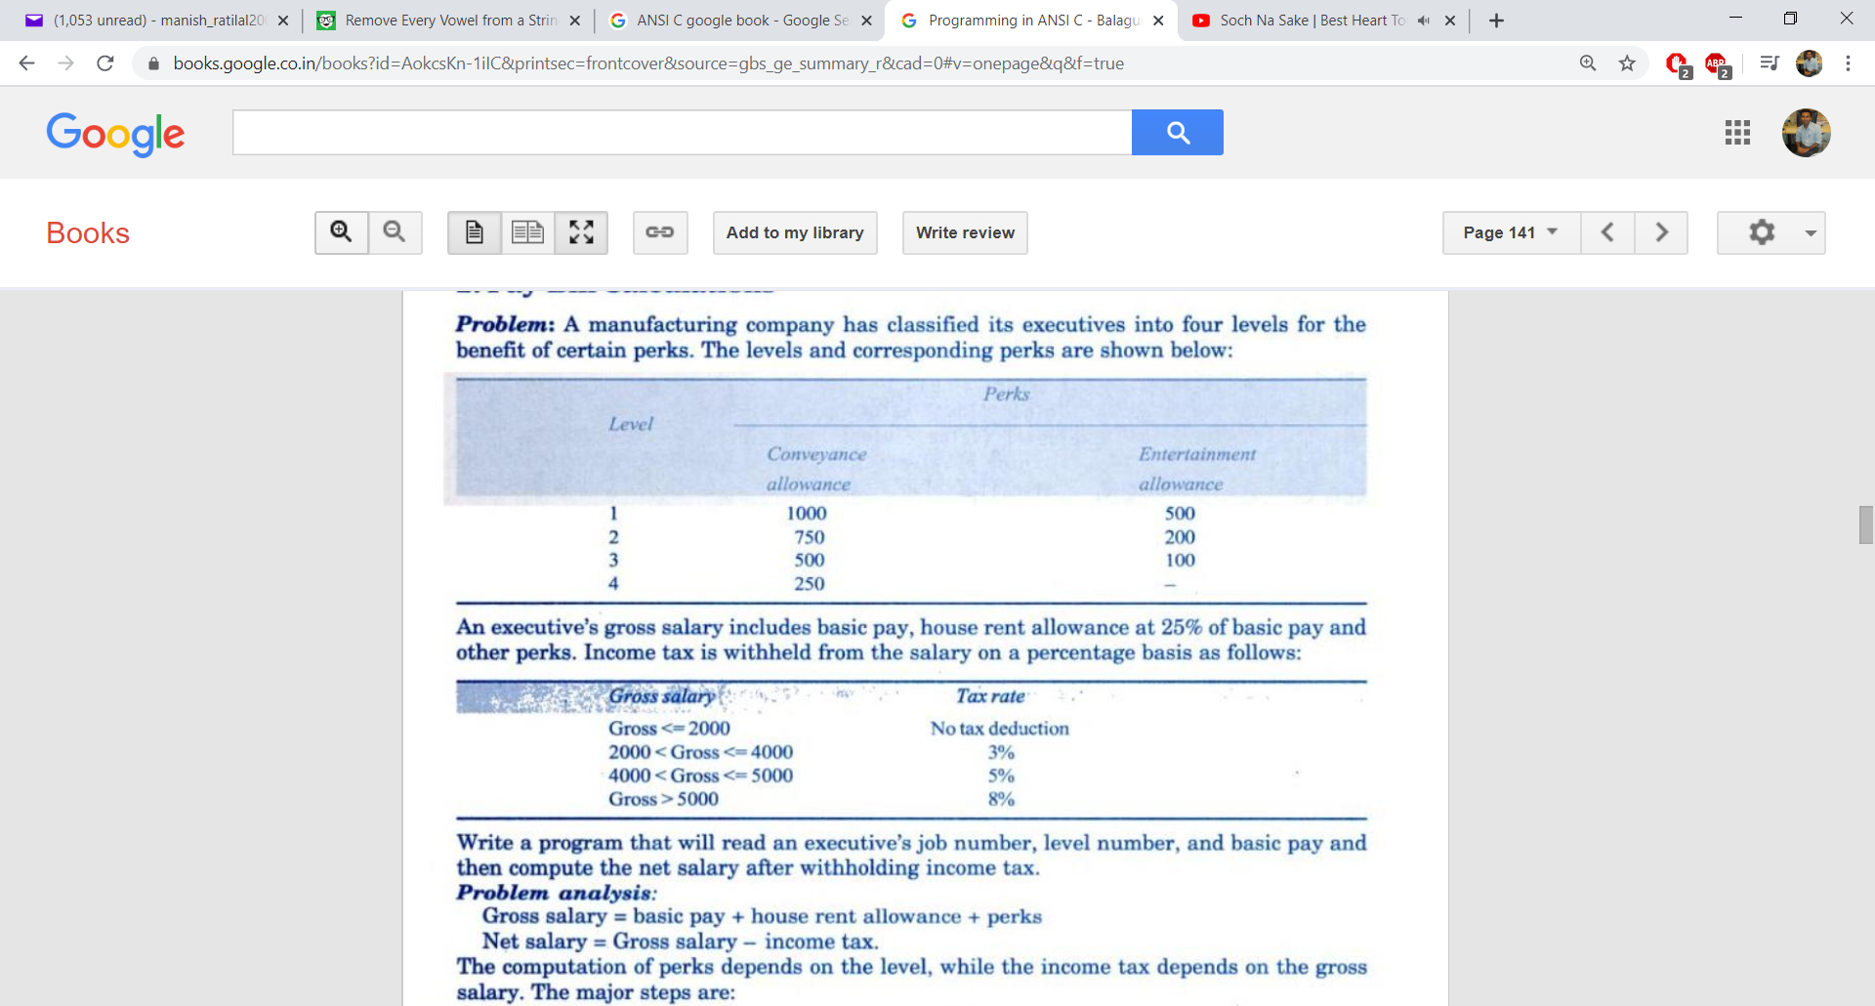

**CO2 related Assignment Questions**

1. Define a class "Person" having data members i.e. id, name and city. Derive a class named "Student" from the class Person, having data members i.e. branch, semester and marks of 5 subjects (using array). Develop a member function "avgMarks()" to calculate average marks of a student. Another class "VisitingTeacher" inherits the class Person, having data members i.e. experience (in years) and rate of lecture per hour. Develop a member function "calSalary()" to calculate the salary by inputting number of hours worked per month. Consider the rate of lecture as 1.5 times for working hours exceeding 40 hours.

**CO3 related Assignment Questions**

1. Write a C++ program to calculate the volume of Cylinder, Sphere and Cone using function overloading.
2. Create a class “Time”, having hours, minutes and seconds as data members. Write a C++ program to add 2 Time objects using operator overloading and display the resultant time on the screen.

**CO4 related Assignment Questions**

1. Write a C++ program to sort a given array of names using pointer-to-array concept.
2. Define a class “Book” having data members i.e. ISBN, title, author, publisher, qty and price. Provide setter and getter methods for the Book class. Develop a member function “searchBook()”, which will ask the book title and will search the book.

Write a C++ program to create array of objects of Book class dynamically and test the functionality of Book class.

**CO5 related Assignment Questions**

1. Create a text file “Numbers.txt” and store some numbers inside it. Create 2 empty text files i.e., “Even.txt” and “Odd.txt”. Write a C++ program which will read one-by-one number from “Numbers.txt” file and if number is even, it should be stored in Even.txt file and if number is odd, it should be stored inside Odd.txt file.
2. Consider “Product” class problem statement. (Covered in practical sessions). Write a C++ program to read Product object details from the keyboard and store the object into the “Products.txt” file. Retrieve the data from “Products.txt” file and display it on the screen. (Use append mode while writing into the file.)